**Epyx FastLoad Cartridge for the C64 Rev. 0**

**Module Description**

This is a cartridge PCB, which is suitable for the Epyx FastLoad software.

This software can be obtained here: <https://rr.pokefinder.org/wiki/Epyx_FastLoad>

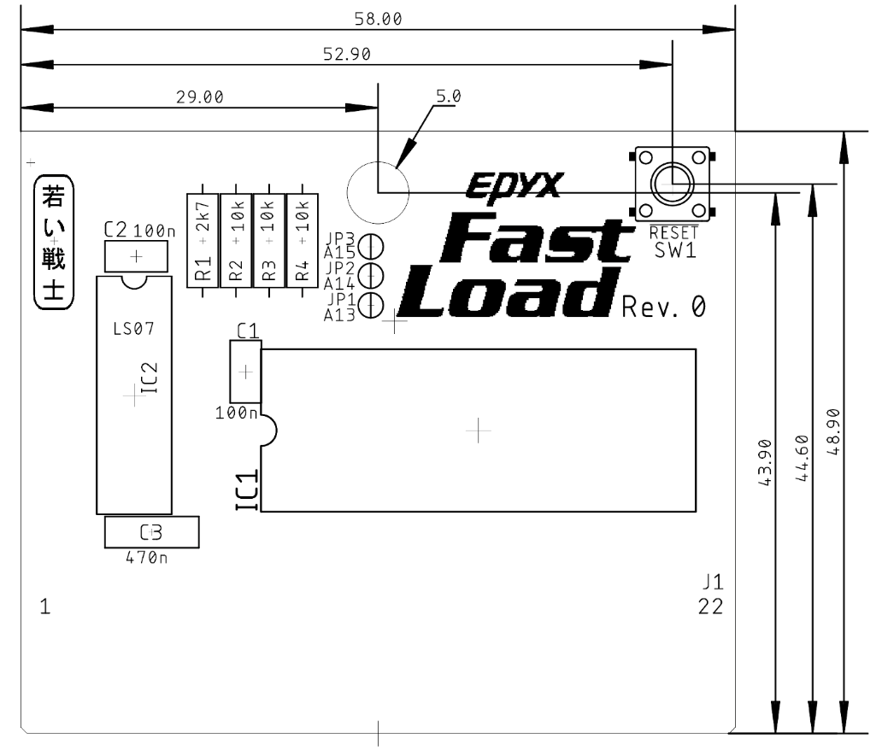

Figure 1: Dimensions

The circuit is based on a schematic found at the source, which was mentioned before.

A RESET button was added to this circuit and solder bridges (JP1 to JP3) for configuring the cartridge for being used with 27C64, 27C128, 27C256 and 27C512 EPROMs for a greater part availability.

|  |  |  |  |
| --- | --- | --- | --- |
| **EPROM** | **Jumper** | | |
| JP3 = A15 | JP2 = A14 | JP1 = A13 |
| 27C64 | open | open | open |
| 27C128 | open | open | close |
| 27C256 | open | close | close |
| 27C512 | close | close | close |

The software is programmed to the EPROM offset address 0x0000 (hex).

The dimensions are equal to the dimensions of the Versa64Cart.